Introduction to Relational Databases

What is a database and DBMS?
Database - A database is an organized collection of structured data. A database is usually controlled by a database management system (DBMS)
DBMS - A database management system (DBMS) is a software system that manages databases. The DBMS allows users to create, read, update, and delete (CRUD) data. It provides the tools necessary to manage and manipulate the database. Popular DBMS examples are: PostgreSQL, MySQL, Oracle and MS SQL

Relational database concepts and terminology
A relational database is a way to organize and store data using tables that can be related to each other. Think of it like spreadsheets where data is stored in organized tables, but with the ability to link related information across different tables.
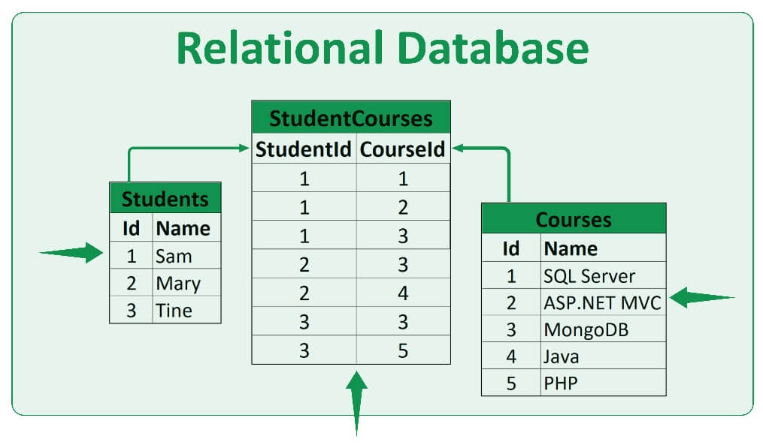

Core Concepts of Relational database
SQL - Structured query language (SQL) is a programming language for interacting with your data in a relational database. In common, all relational DBMS have SQL support. Otherwise DB without SQL support is considered as a NoSQL DB.
Table - A collection of data organized in rows and columns, like a spreadsheet. Each table represents a specific type of information of the entity (like "Students" or "Courses" on my-alatoo system).
Row - A single record in a table containing all the information about one item. For example, one row in a "Students" table might contain all the details about one specific student.
Column - A category (or field name) of information that applies to every row in the table. In a "Students" table, columns might include "Student ID" "Name" "Email" and "Faculty"
Primary Key - A unique identifier for each row in a table. No two rows can have the same primary key value. It's like your student ID number - each student has exactly one, and no two students share the same student ID number
Foreign Key - A column in one table that refers to the primary key of another table. This creates the "relationship" between tables. For example, a "Course Enrollment" table might have a "Student ID" foreign key that points to the primary key in the "Students" table.
Important Terminology
Schema The blueprint or structure of your database, defining what tables exist, what columns each table has, and how they relate to each other.
Query: A request for specific information from the database, usually written in SQL (Structured Query Language). It's like asking the database a question.
Index: A behind-the-scenes tool that makes searching through large amounts of data much faster.
Normalization: The process of organizing data efficiently to reduce redundancy and ensure data integrity. Instead of storing the same information multiple times, you store it once and reference it from other tables.
Relationship Types:
- One-to-One: One record in Table 1 relates to exactly one record in Table 2
- One-to-Many: One record in Table 1 can relate to multiple records in Table 2
- Many-to-Many: Multiple records in Table 1 can relate to multiple records in Table 2

NoSQL database overview
NoSQL databases (Not Only SQL) are a type of database that differs from traditional relational databases in that they have a more flexible structure and use different data storage principles.

Main types of NoSQL databases:
- Document databases (MongoDB, CouchDB) - Store data in the form of documents (usually JSON-like structures) that can contain nested objects and arrays.
- Key-value (Redis, DynamoDB) - The simplest model, where each unique key corresponds to a specific value.
- Columnar (Cassandra, HBase) - Data is organized in columns, which optimizes analytical queries and compression.
- Graph (Neo4j, ArangoDB) - Specialized in storing and processing relationships between objects represented as nodes and edges.

Key differences from SQL databases
Data structure:
SQL - Rigid schema with predefined tables, columns, and data types
NoSQL - Flexible or no schema, allowing for the storage of heterogeneous data

Scalability:
SQL - Vertical scaling (increasing server power)
NoSQL - Horizontal scaling (adding servers to the cluster)

ACID vs BASE
SQL - Strict adherence to ACID principles (Atomicity, Consistency, Isolation, Durability)
NoSQL - Often follows BASE principles (Basically Available, Soft state, Eventual consistency)

Query language
SQL - Standardized SQL language
NoSQL - Specific APIs and query languages for each system

Data consistency
SQL: Strict consistency
NoSQL: Often eventual consistency (final consistency)

SQL vs NoSQL
When to use NoSQL:
- Working with large volumes of unstructured data
- Need for rapid horizontal scaling
- Developing applications with frequently changing data structure requirements
- Highly loaded systems with performance requirements
- Working with geographically distributed data

When to prefer SQL
- Complex transactions with strict consistency requirements
- Established data structure with complex relationships
- Need for standardized tools and team skills
- Financial systems where data accuracy is critical
- The choice between SQL and NoSQL depends on the specific requirements of the project, the nature of the data, and the expected loads.

ACID properties overview
ACID is a set of properties that ensure the reliability and predictability of transactions in relational databases:
Atomicity: Each transaction is either fully executed or not executed at all. If one of the actions cannot be completed, all changes are rolled back.
Consistency: After a transaction is executed, the database always transitions from one consistent state to another.
Isolation: Simultaneous execution of transactions should not affect data integrity.
Durability: After a transaction is confirmed (committed), its changes are saved even in the event of system failures.
ACID guarantees data integrity and makes SQL databases convenient for critical applications (e.g., banking systems).

About PostgreSQL
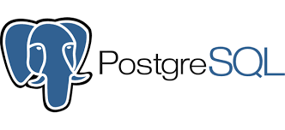
In our tutorial we will use PostgreSQL as our DBMS.
PostgreSQL originated in 1986 as the POSTGRES project at the University of California, Berkeley (led by Michael Stonebraker). In 1996, it gained SQL support and was renamed PostgreSQL. Nowadays it’s one of the most popular and robust DBMS used by big corporation (e.g MAANG)

Features of PostgreSQL:
- Full ACID support.
- Extensibility support: you can create your own data types, indexes, and functions.
- Rich JSON and XML capabilities, allowing PostgreSQL to be used as both a relational and document DBMS.
- Support for stored procedures and functions in different languages (PL/pgSQL, Python, C, etc.).
- Active community and regular updates.
- Replication and sharding for scalability.
- Used as an open-source alternative to Oracle in large projects.

Comparison with other database systems
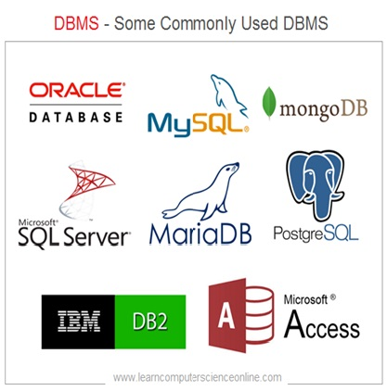
PostgreSQL:
Open-source, powerful, SQL-compatible, extensible, good for complex systems requiring reliability and transactions.

MySQL:
Very popular, easy to install and use, well suited for web applications (e.g., WordPress). However, it traditionally lags behind PostgreSQL in functionality and SQL standard compliance (although this has improved in recent versions).

SQLite:
Embedded database without a server component. Very lightweight and convenient for mobile applications and prototyping. However, it is not designed for high loads and multi-user systems.

Oracle Database:
A commercial and very powerful system used by large corporations. Supports huge loads, complex transactions, and analytics tools. The downside is the high cost of licenses.

Thus, PostgreSQL has none of the drawbacks of alternative solutions — it is more powerful and reliable than MySQL, but free unlike Oracle, and at the same time not as “lightweight” as SQLite.

